The Good Shepherd Catholic School

Join us on Thursday, September 29th for our annual Open House
The school will be open from 5pm-7pm
(classrooms will be open from 6-7pm unless otherwise specified by your child’s teacher)
Don’t miss out on signing your Annual Offence Declaration Forms. Any parents/guardians wanting to volunteer in the school this year must have a Criminal Background Check on file and an Annual Offence Declaration form signed each year. This is necessary if you want to attend a field trip with your child’s class. Stop by the front foyer during the Open House to sign your paperwork!

The Scholastic Book Fair will be in our school library during the Open House. Stop in and buy some books to keep your child reading this year!
Ask about the Family Draw- you could win $50 in books for your family and your child’s classroom!

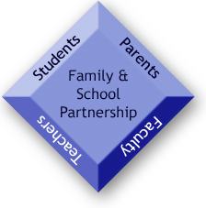
Stop by the CSCC table and learn how you can get involved in our parent council.
Find out more information on our year-long gift card and Bradford Greenhouse fundraisers.

Don’t forget to stop by the Spirit Wear table to order your School Jersey!
Shirts will be available to try-on.

Enjoy a pizza dinner while at the Open House
Orders for pizza will be taken in advance. Please tear off this order form and return it to the school by Tuesday, September 27th. Pizza will be served in the gym from 5-6pm.
Drinks will be available to purchase at the Open House for $1.00 each

Family Last name: _______________________________________

Number of slices ($1.50 each): _________________________

Cash or cheque amount enclosed: ________________

