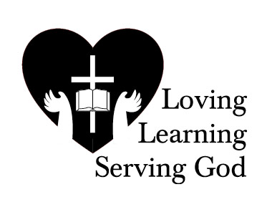

November 2, 2016

Dear Parents and Guardians of The Good Shepherd Catholic School,

We will be holding Parent-Teacher Interviews at the school on Thursday, November 17th from 3:30 -

8:45 pm and Friday, November 18th from 8:45 - 3:00 pm. This year, you will be able to schedule your Parent-Teacher Interviews online. If you wish to schedule a meeting with any of your child's teachers, please follow the instructions printed further down the page.

You will be able to make appointments from November 8th at 9:30 am to November 17th at 12:00 noon.

**Instructions**

1. Go to the The Good Shepherd scheduling webpage at <https://tgscs.parentinterview.com>

2. Enter the Parent Code (printed below), click "Sign In"

Please make a note of your Confirmation #

3. Fill in your contact information and click "Continue to Make Appointments"

4. Click on the name of a teacher with whom you wish to schedule an appointment

5. Click on "Available" for a time at which you wish to meet to have your meeting

6. Repeat Steps 4 and 5 until you have scheduled all the teachers you wish to meet

7. Click on "My Schedule" (top left of the page)

8. Print out, email or copy down your schedule and bring it with you

**The Parent Code for this term is**

**good16**

**Do not share this code with anyone outside your school community**

Should you wish to delete an appointment you have made, click on "Delete" beside the meeting you wish to have removed from your schedule. If you decide to delete an appointment, that time slot will become available for other parents. There are no guarantees that you will be able to reschedule that appointment.

If you misplace your schedule, you may use your Confirmation # to retrieve your schedule from the website at any time. If you need help using the service, please email [support@parentinterview.com](mailto:support@parentinterview.com)

If you do not have access to the internet at home or in the workplace, please call parent Interview toll-free at 1-866-810-0076, and someone will be happy to make your appointments with you.

We look forward to seeing you.

Sincerely,

The Teachers and Administration of The Good Shepherd Catholic School